GOLDEN LEAF HANDICRAFTS

Category - Rangoli

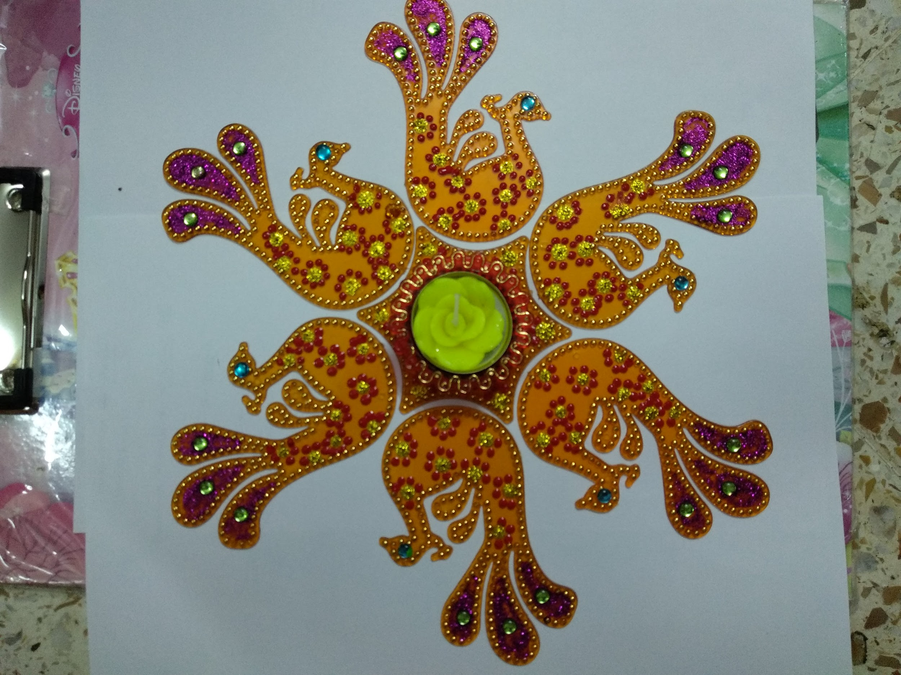

This simple and sobar rangoli will definately make your homes more beautiful. Also it can be beautifully used as a wall-piece too. (Also available in green colour)

Purchase it just at Rs.349/-.

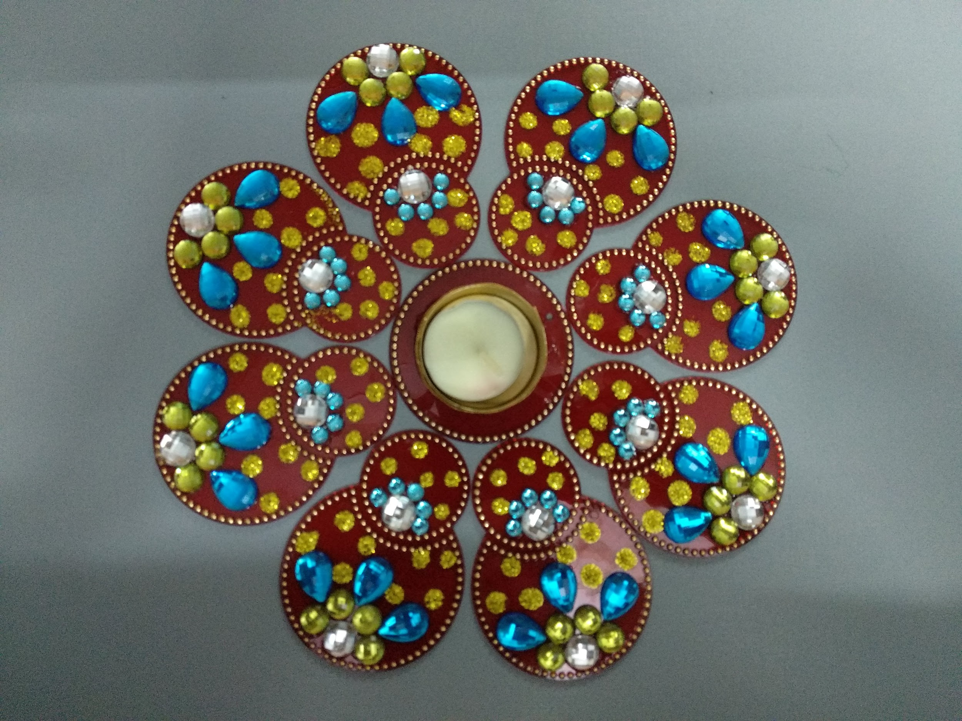

Our vibrant red rangoli-cum-wall-piece will help you bring auspicious vibes in your homes.

Purchase it just at Rs.549/-.

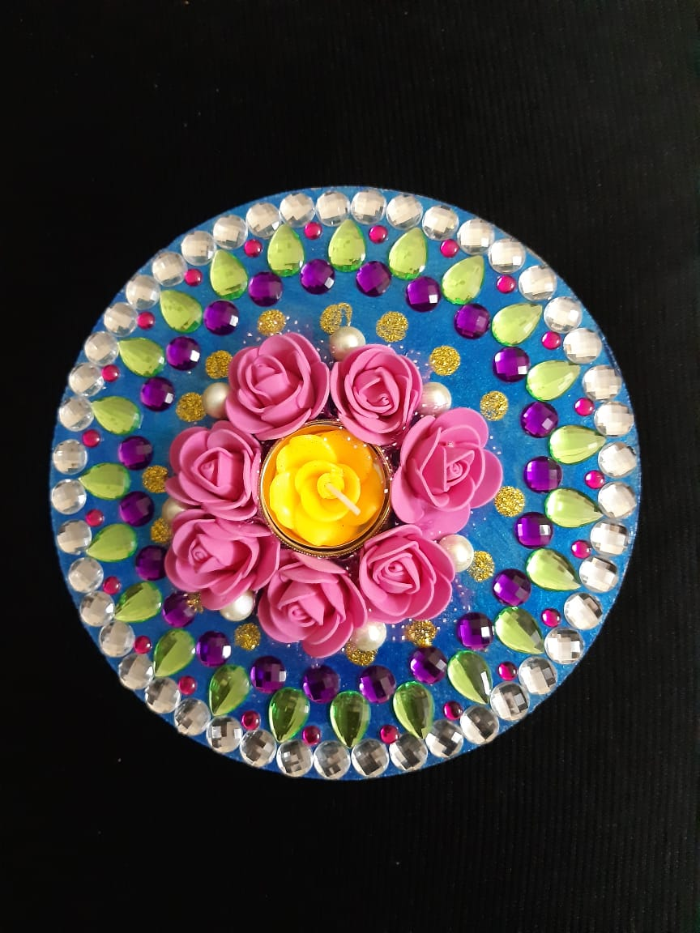

A unique piece of art. This beautifully decorated rangoli with roses and pearls will help you invite home a good omen.

Purchase it just at Rs.499/-.

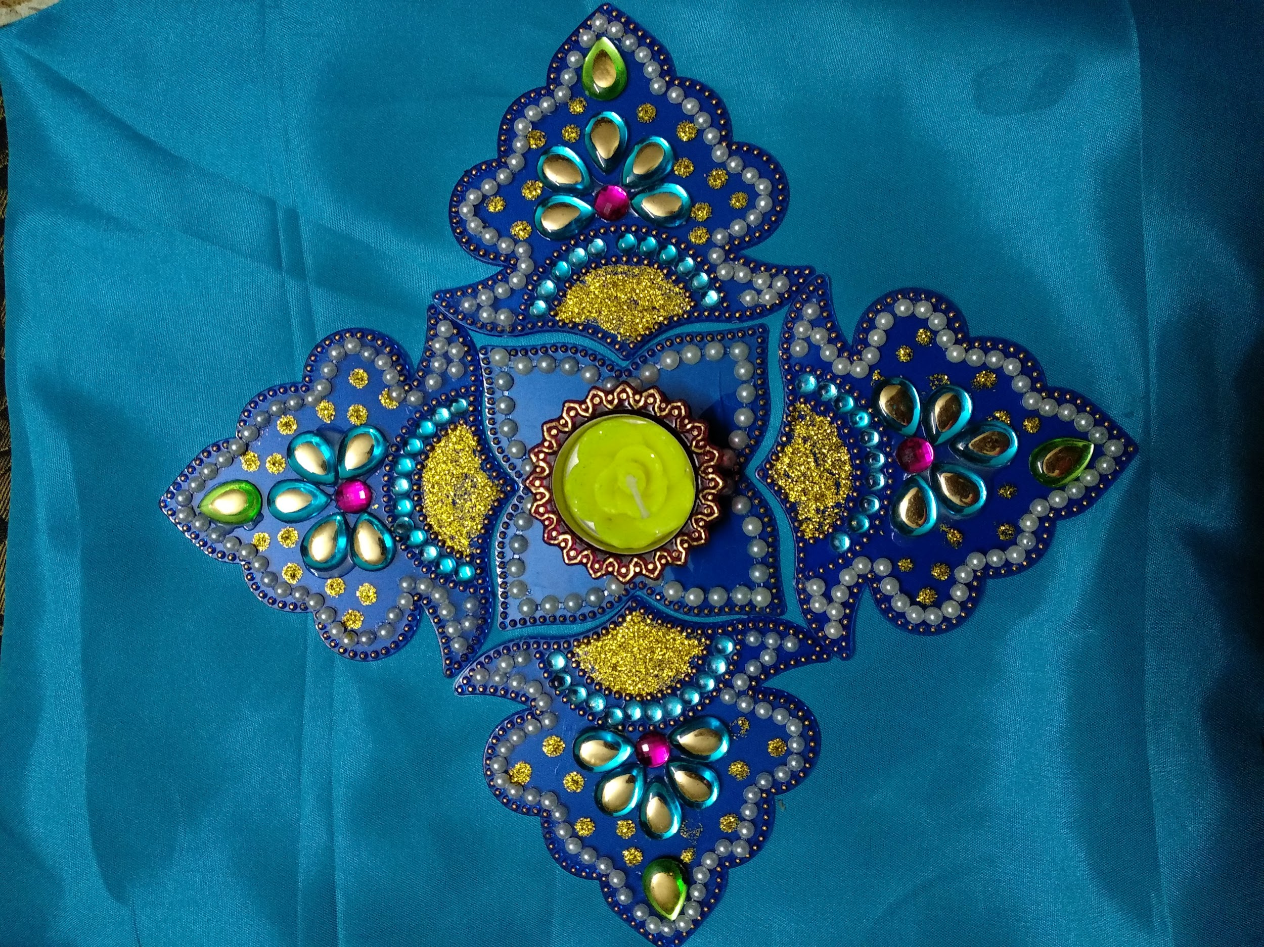

This beautiful rangoli-cum-wall-piece looking like peacock feathers will enhance the beauty of your doors and homes.

Buy them now at just Rs.449/-.

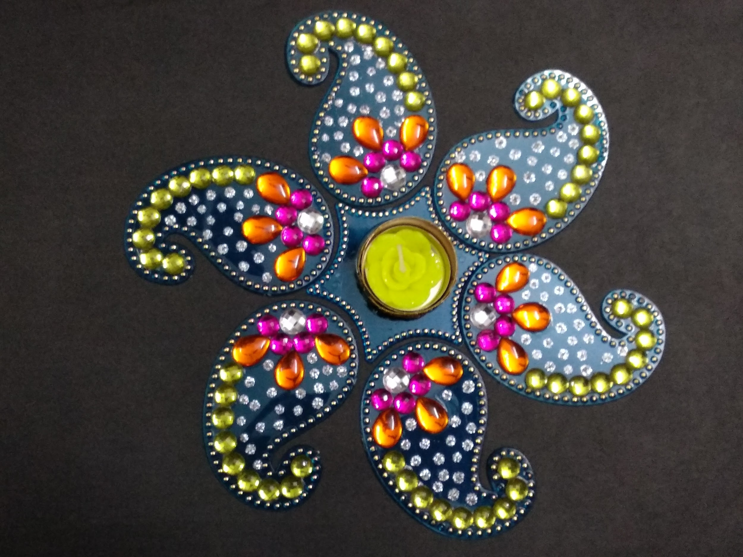

On auspicious occasions and festivals, Indian homes are decorated with rangoli. Decorate your homes with this beautifully handcrafted rangoli which can be also used as a wall-piece.

Purchase it just at Rs.499/-.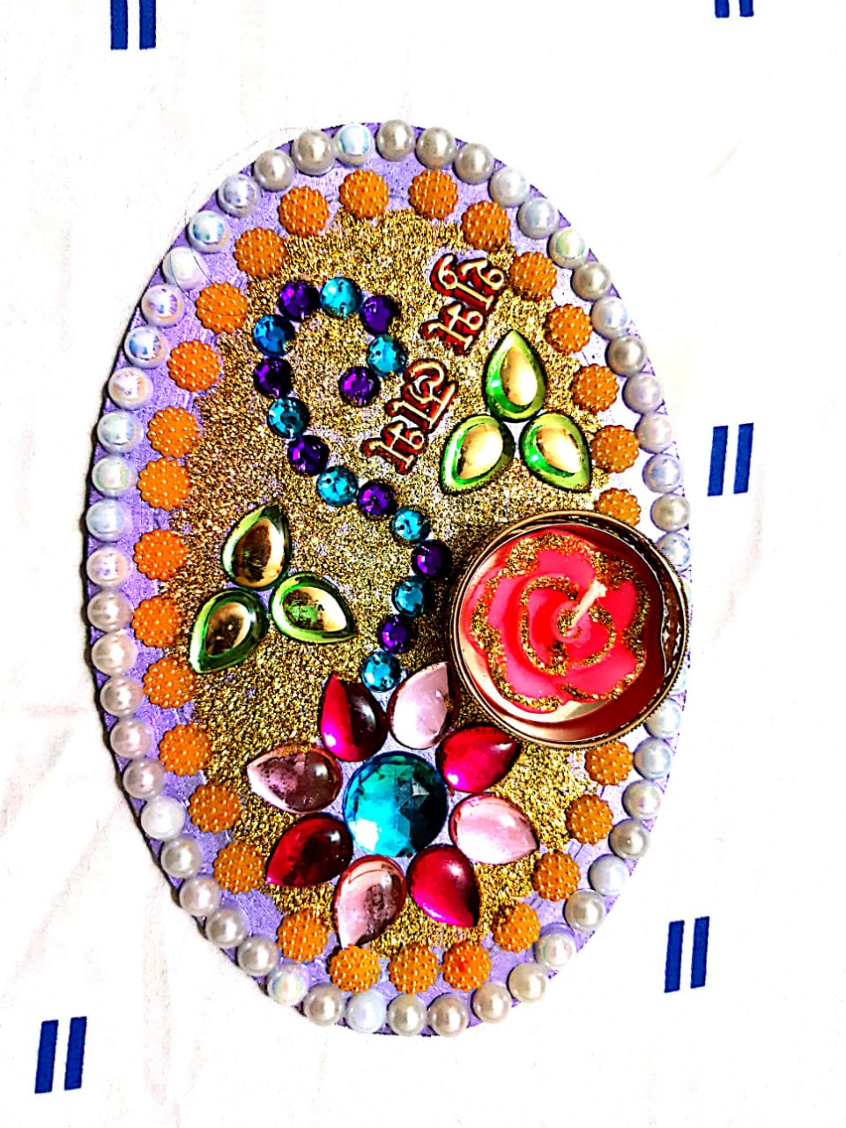

This oval shape handcrafted rangoli-cum-shubh-labh will not only ward off evil, but will also bring prosperity at your doorstep.

Purchase it just at Rs.299/-.

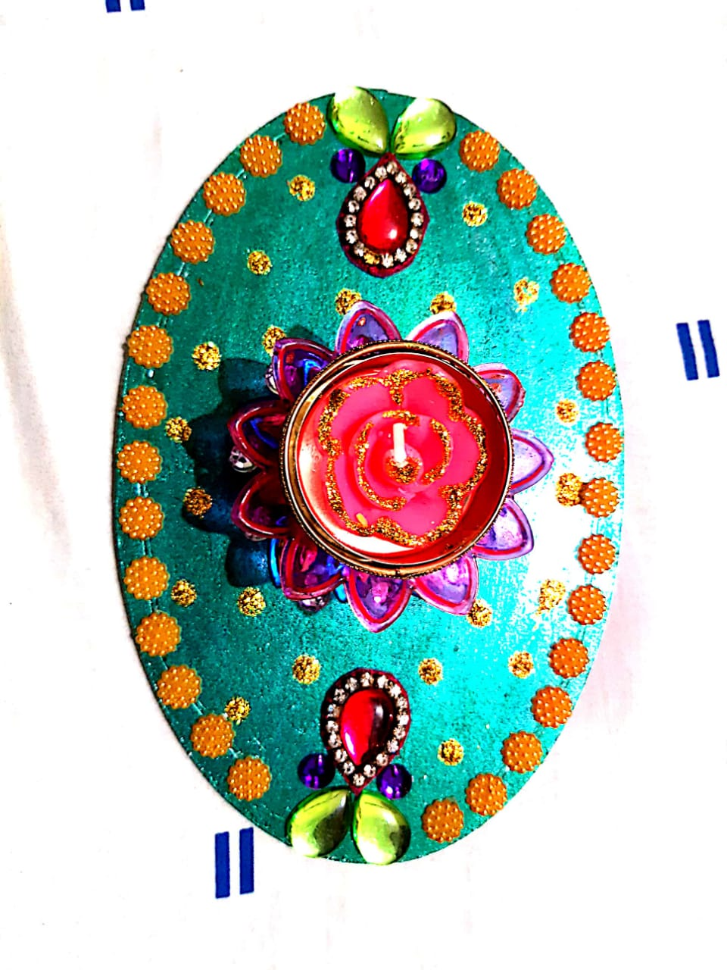

This beautifully decorated oval shape rangoli will enhance the beauty of your doorstep.

Purchase it just at Rs.299/-.

s.299/-.

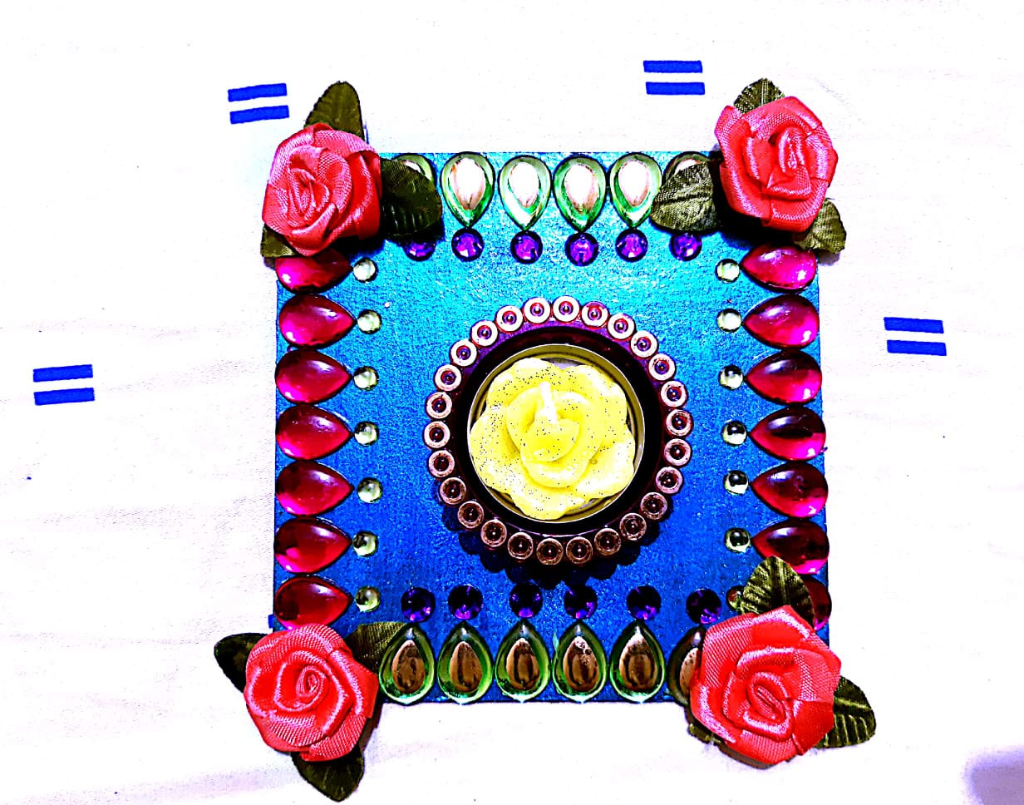

This beautifully decorated rangoli with roses and beads will definately catch your glimpse.

Purchase it just at Rs.125/-.

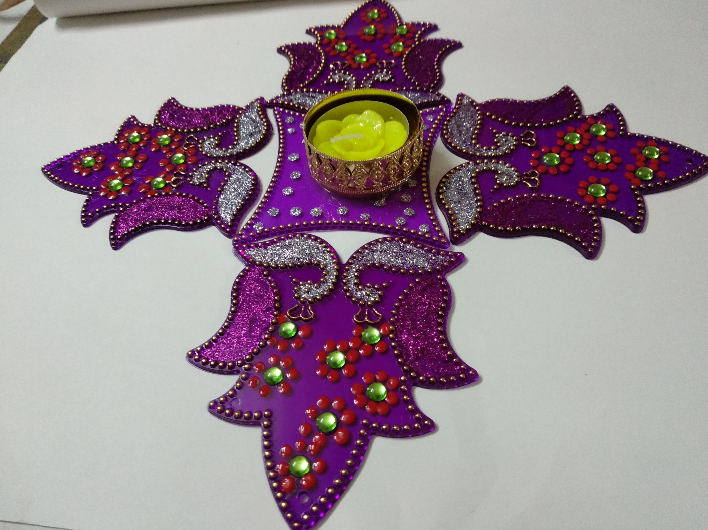

Flow designs have a universal appeal. This diverse art form cuts across regional boundaries. Bring home the national bird to decorate your doorsteps with this vibrant and colorful rangoli-cum-wall-piece.

Purchase it just at Rs.249/-.